Bumanglag, Angeline D. BSCS-C203 Mangalino, Chriselle C. 10/01/2025

Midterm Lab Task 6 (Constructor Activity)

PROBLEM # 1

CLASS – MONEY:

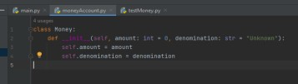

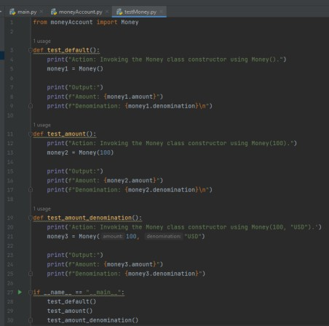TEST CLASS:

OUTPUT:

